YOUR GUIDING LIGHT
South Australian Tourist Guide Association
SATGA NEWSLETTER
SATGA Secretary: satgasecretary@outlook.com Editor: Peter Tamm
www.satourguides.org.au peterktamm@gmail.com

NEWSLETTER No 93 August 2024

Greetings from your Editor,
With the focus on the Olympic Games during the past 16 days one can be forgiven to ignore other activities, but tourism highlights always make the news. Adelaide has been recognised once more taking the top spot in world rankings, this time via the “Architectural Digest”. I shall detail this news in a separate article.
Our SATGA committee has been busy organising an educational familiarisation to the Barossa Valley early in August and I like to welcome Monica, Jane and Sally who joined other SATGA members. Commentary was shared amongst our experienced guides but also the driver Ralph who added snippets of interest and fun. A thank you to Christopher and his contacts for arranging transport and also Jo and Di for picnic supplies and reminder information.
The two pick-up points in Adelaide made it convenient for parking and the planned route gave our new guides a good look at some of the highlights included in most itineraries.
The Whispering Wall via the historical township of Gawler was followed with a visit to the Jacobs Creek Visitor Centre where we received the news that ownership has passed from French company Pernod Ricard to the Australian multi conglomerate Accolade Wines.
Mengler’s Hill Lookout is a must for a great view of the Valley and regional Cheese tasting in the main street of Angaston was another welcome break. We visited Maggie Beer’s produce outlet and concluded our day at highly impressive Seppeltsfield. This is a multi-interest location where history meets art and virgin olive oil products. Not forgetting wine tasting and the opportunity to sample a 100 year old Port wine at current price of $100 a nip.
Depending on time available for the return to Adelaide different routes may be explored with the help of the coach captain on the day of the tour. Our new prospective guides no doubt have returned with a full compliment of touring knowledge, but should never be shy to ask questions.

Barossa Valley Famil.

The day outing was designed to help guides with a practical step in to a typical tour from Adelaide to the Valley.
Sights, visits to wineries and lunch bookings may vary and timing will be subject to departure and specific destinations. For all guides the preparation and liaison with planners, organisers and coach operators is the key to a successful tour. 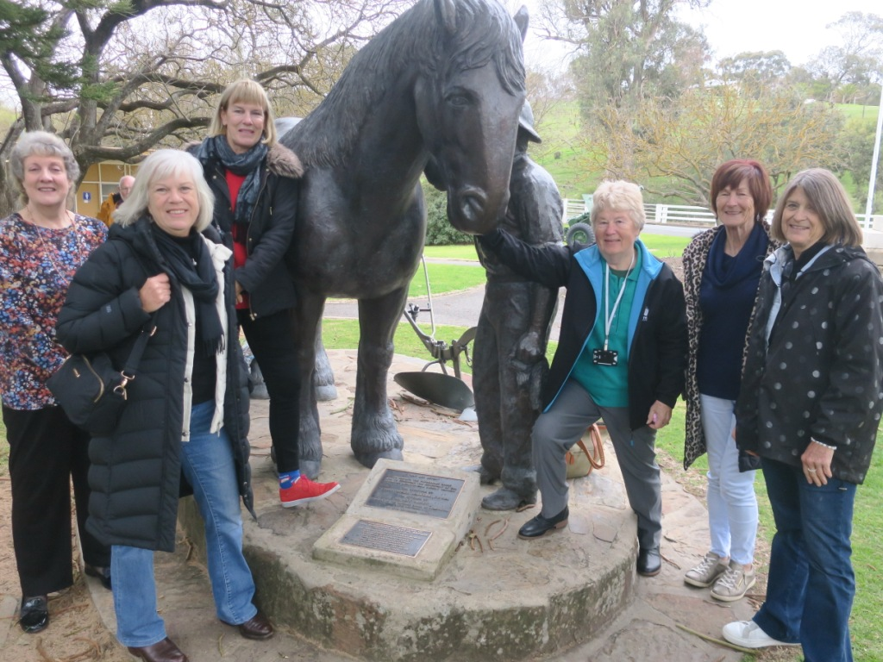
Angaston Lunch Stop
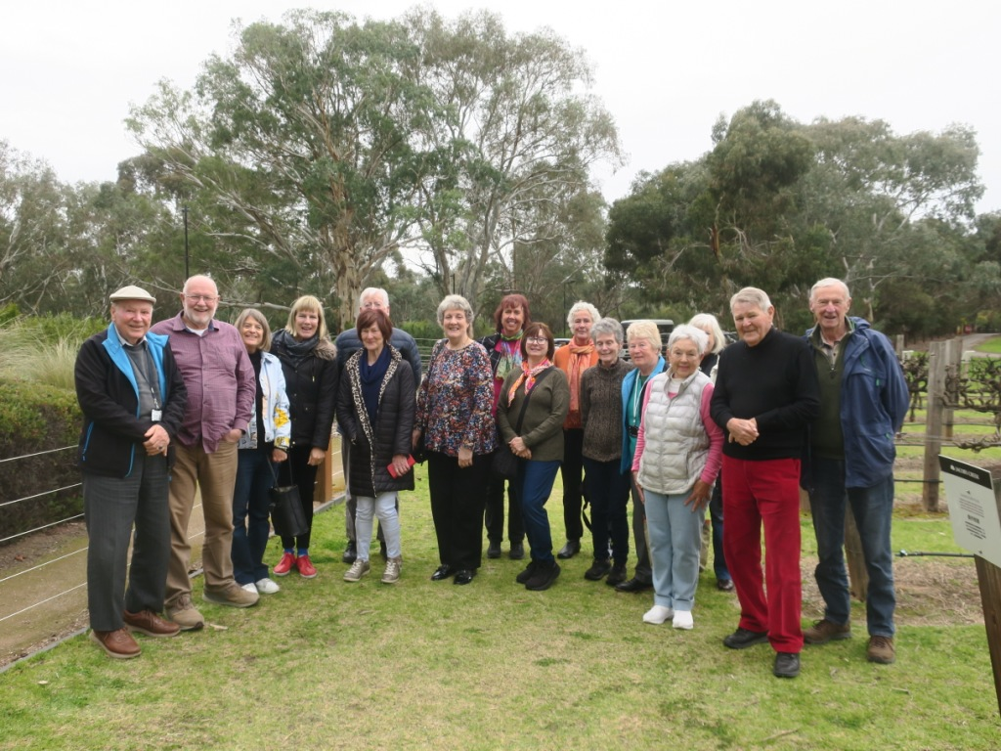
Our group at Jacobs Creek (Orlando) display Vineyard, Barossa Valley
P.T.

.

he

-1-1
G

-2-

Overland to Campbelltown

When Charles Campbell made his way from Sydney to Adelaide as a member of the party that in 1840 accompanied Joseph Hawdon and Charles Bonney to drive livestock overland from NSW the event was described as the most interesting and important since SA settlement.
After arriving in Adelaide he expressed satisfaction that his party had succeeded in “preserving the utmost friendship with the natives along the way” which was not always the case with other overlanders.
Charles James Fox Campbell was born in Lismore, Scotland on the eastern side of Loch Linnhe on 9 January 1807. When his father John emigrated in 1821 to NSW he was given a grant of 2,000 acres west of Parramatta assisted by the influence of the family connection with Elizabeth Macquarie. This property used for breeding horses and stocking cattle was one of the sources to supply Adelaide with livestock. When Charles eventually settled down in Adelaide he would purchase land along the Torrens and build a home named Lochend linking the name to his grandfather - John Campbell of Ardeonaig and Lochend - This villa built in four stages from bluestone has six rooms with a 4 acre garden surround. His friend George Strickland Kingston who settled as architect after surveying is credited with some of the design. Lochend is usually on the list of exhibits open to the public during our history month of May. Prior to settling down and also taking on such duties as judging horse races as well as acting as a magistrate, Charles combined in pastoral activities establishing a sheep run at Hill River near Clare ( today a quality Riesling producer).
He acted as the chief judge at Adelaide’s first Grand Steeple Chase on 23 September 1846 with the starting point fixed near the Glen Osmond lead mines and attended by about a thousand people on horseback, in carriages or on foot. Charles Campbell died on March5, 1859 at North West Bend from a cut to his head that turned septic.

P.T.

Adelaide Top Again

The International Design Magazine “Architectural Digest” has named Adelaide at the top of their list of the 20 most beautiful cities in the world.
The mix of criteria to achieve this includes: Architecture, Cultural Treasures, Historical Relevance and Natural Appeal. Adelaide is the only Australian City to make it on this list, it is also the only Australian capital to have a original plan.
The article points to the ease that visitors can experience “Surf Sand and Dunes”, Art Deco Architecture, rolling hills, wildlife and a choice of some of Australia’s top wines.
All of this pleasure within short distances of Adelaide’s Centre. Other names in the top 20 included Estonia’s capital Tallinn surrounded by a protected wall going back to the 11th century.
No 3 was Portsmouth in the Dominican Republic not the UK. Their main asset was sustainability using local products constructing main buildings as well as providing food from the farm to the table.
Singapore ranked 6th and you would agree from the point of landing at Changi Airport now proudly displaying the worlds highest indoor waterfall. Also Paris, one of the most visited cities in the world came in as No 7 on the list.
Note: we hope our neighbour cities take note.

Normanville
Here is a much underrated tour destination that can easily be linked to the MacLaren Vale region with perfect beach and a brand new Restaurant called Aqua Blue. They have no problems with catering for groups and it would be a hit for overseas visitors.

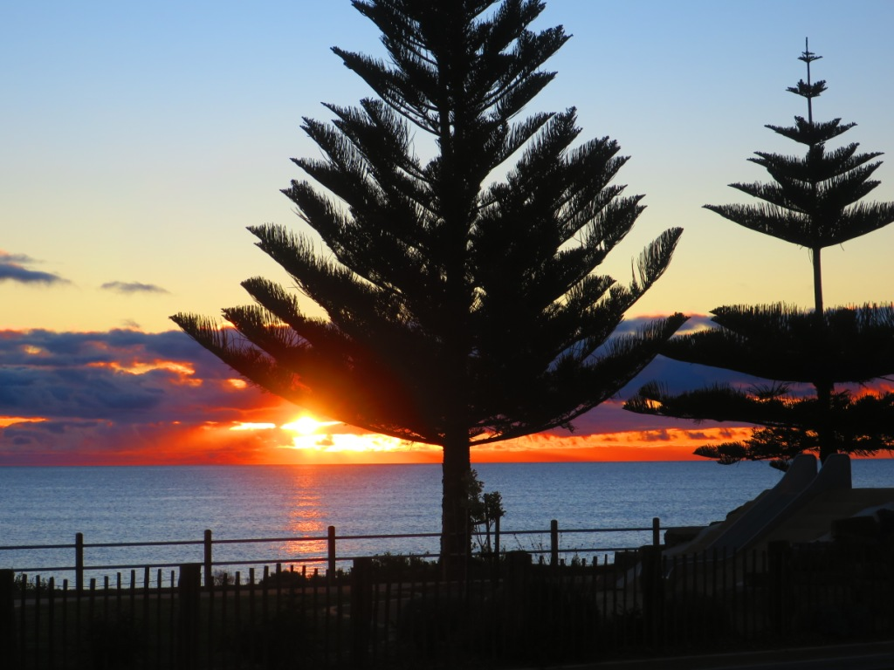
Sunset at Normanville
P.T.

-3-

The Adelaide Pound Story

Lachlan Macquarie arrived in Sydney Cove on the last day of 1809 and was declared Governor of the colony of NSW on 1st January 1810. He inherited many problems including extreme shortage of currency, To rectify this to a degree 40,000 Spanish silver dollars were sent via Madras in 1812. By punching out the centre of the coin, called “a dump” a smaller currency was created to further payment exchange. Much late in the history of Australian coinage the SA Government faced a different problem, that of how to turn gold dust and bullion arriving from the Victorian gold rush into currency. Therefore in 1852 the Adelaide Assay Office used the authorised newly created Bullion Act to mint ingots, followed by the Adelaide Pound Type I and Type II. These are the first coins produced in Australia from Australian ore, with an entirely Australian design and created without Royal permission Due to a crack in the minting process of Type I only a few made it in circulation (today’s value would be about $150,000). The Type II had an issue of over 20,000 and it’s a mere $45,000 if you have one hidden away. P.T.
Canals awash with rats and rubbish
Amsterdam is drowning under tourist-generated rubbish and is overrun by rats and seagulls, complain its residents. The Dutch capital welcomed more than 20million visitors last year – twice as many as Venice - who left behind an almighty mess, The city has become one of the dirtiest in the world and the problem was illustrated by the weekends Pride Celebrations, during which 73 tonnes of rubbish was collected after only 1 day. Like Prague, Venice and Barcelona, the city is trying to move away from mass tourism and focus on smaller numbers of higher spending visitors with longer stays. More than 1,000 cruise ships arrive each year bringing a large number of “nuisance tourists”. I hope we never have that problem here. P.T.
Events around Adelaide

August 1-31
SALA Festival

September 20-October7
Grenache and Gourmet Festival
MacLaren Vale

August 31-September 8
Royal Adelaide Show
Wayville

August14-31
At the Festival Theatre
Chicago

October 24 – November 10
Ozasia Festival

Early notice

September 3rd
Meeting with Cruise Guides Staff
for anyone wanting to find out latest requirements attached to tourist guiding, referred to as a training session
note: no details of time and venue as yet

Andrea has forwarded the following details for our AGM booked for Wednesday, December 4th at:

The Queens Room, Adelaide Town Hall
5:00pm – 7:00pm

The Guest speaker will be Dr Jane Lomax-Smith

Lord Mayor of the City of Adelaide

